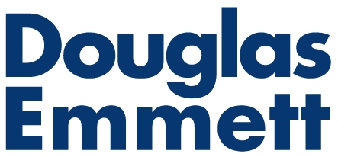 | BUILDING ACCESS REQUEST FORM
 | Form CT-06 | Wilshire Bundy Plaza

To request access to the building for deliveries and when moving in and moving out, please complete this form, attach the Certificate of Insurance for your vendor, have an authorized person sign it and return it to the Office of the Building.

Tenant Name: |  | Contact Phone #:
Suite No.: |  | Date:

Your move must comply with the Building Moving/Delivery Policy, a copy of which can be obtained from the Office of the Building.

VENDOR (For access by a vendor, contractor, delivery personnel, you must attach their Certificate of Insurance.)
Vendor Name: |  |  |  | Phone #:
Vendor Contact Person: |  |  |  | Suite No.:
Vendor Address: |  |  |  | Date of Access:
Freight Elevator Needed: | Yes | No | From: To:
Loading Dock Access Needed: | Yes | No | From: To:
Certificate of Insurance submitted to Office of the Building: | Yes | No | Certificate of Insurance expiration date:
Description of physical work to be performed:

Please understand that your move is not scheduled until confirmed by the Office of the Building.

Tenant has reviewed and agrees to the Building Moving/Delivery Policy, and understands that it is responsible for any damages to the Building or any other person or property.

Tenant Authorized Person: | Signature:
Tenant Authorized Person: | Type/print name & title:

