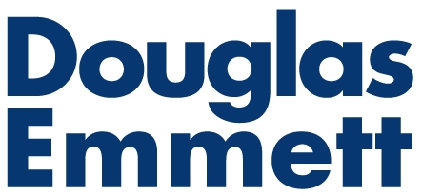 | CERTIFICATE OF INSURANCE REQUIREMENTS FOR VENDORS
 | Wilshire Bundy Plaza

All companies or individuals performing services must provide a valid Certificate of Insurance, together with an Endorsement that certifies the submitted certificate is a valid document, to the Office of the Building prior to commencement of any work.
Please ensure that the certificate you submit is completed accurately and in accordance with the requirements stated below.
REQUIRED ENDORSEMENTS:
Location: | The physical location/address where the work is being performed must be indicated on the Certificate of Insurance.
Certificate Holder:  The following party must be named as a Certificate Holder on your policy | DE 12121Wilshire, LP  12121 Wilshire Boulevard, Los Angeles, CA 90025
Additional Insureds:  The following parties must be named as an additional insured on your policy | Wilshire Bundy Plaza  Douglas Emmett, Inc.  Douglas Emmett Management, Inc.  Douglas Emmett Management, LLC  Douglas Emmett Properties, LP
Cancellation and Notice Language: | The Certificate of Insurance should provide 30 days written notice of cancellation or material modification without a disclaimer and read:  “Before the stated expiration date the company will not cancel or reduce the insurance afforded under the above policies until at least 30 days notice of such cancellation has been mailed to the certificate holder.”
All required insurance must be maintained with acceptable insurance companies licensed to do business in the state in which the Property is located with a rating of not less than a VII as rated in the most currently available “Best’s Insurance Guide”.
MINIMUM COVERAGE LIMITS:
Commercial General Liability: | On an “occurrence” basis for bodily injury, death and property damage liability including (1) owners’ and contractors’ protective liability, (2) products / completed operations liability, (3) broad form property damage liability, and (4) broad form contractual liability with a combined single limit of not less than One Million Dollars ($1,000,000.00) per occurrence and Two Million Dollars ($2,000,000.00) in aggregate.
Commercial Automotive Liability: | Combined single limit of not less than One Million Dollars ($1,000,000.00).
Workers Compensation: | Statutory limits as required by the laws of California.

Acceptance of any Certificate of Insurance does not relieve you from your obligations with respect to insurance, nor does it limit or relieve you of any of your other duties or responsibilities. For your protection, please consider whether you should obtain higher insurance limits. Remember to provide evidence of renewal or replacement of any required policy not less than thirty (30) days before it expires or is cancelled.

